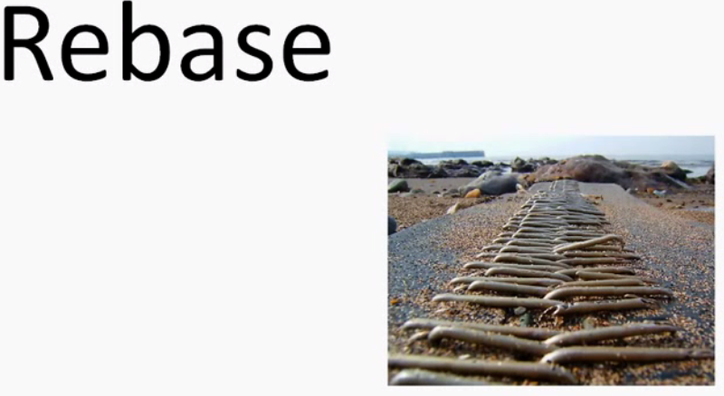

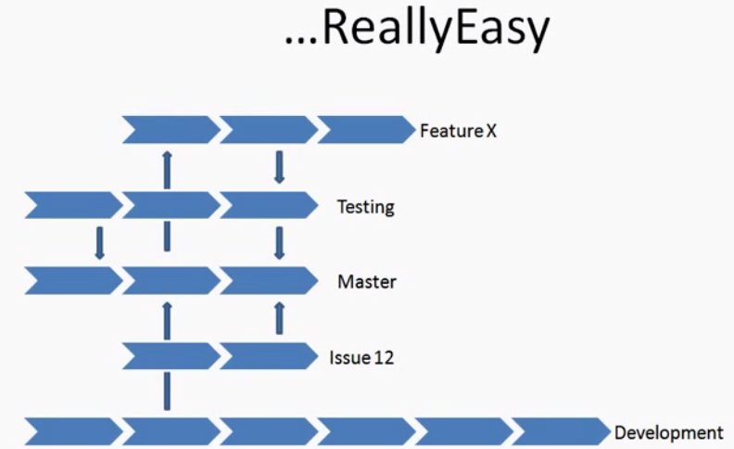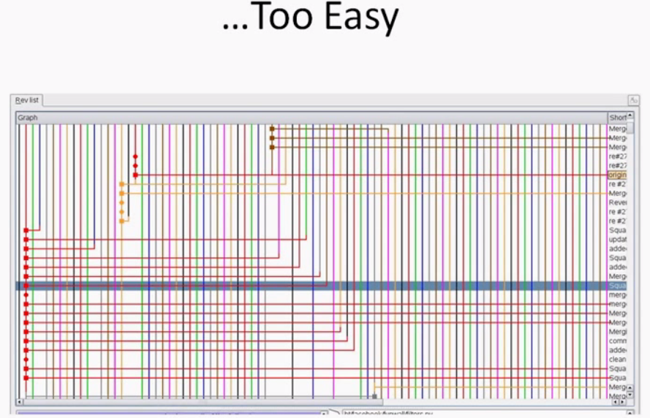Quite a large project.. Suppose if we want to integrate branch into Project Master branch…SO REBASE

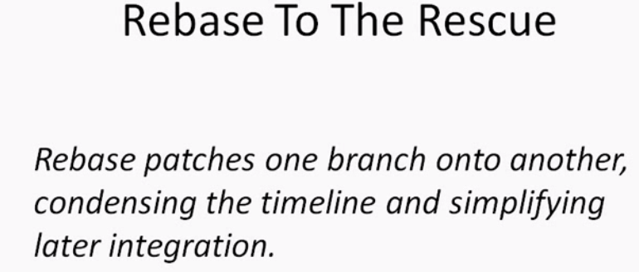

Let say we are working with team.N/W Share Origin/master.

Clone to local. Create Devt branch.., later so soso onn..Later we merge to MASTER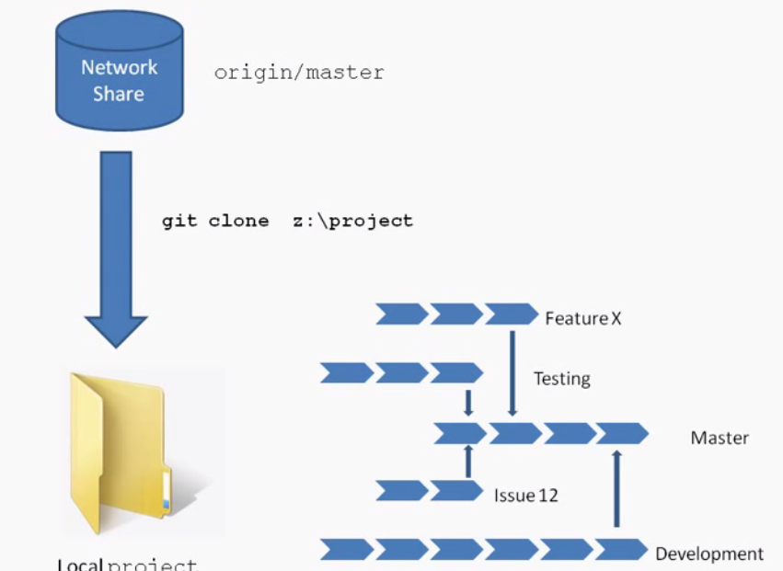

We will push back to N/W share.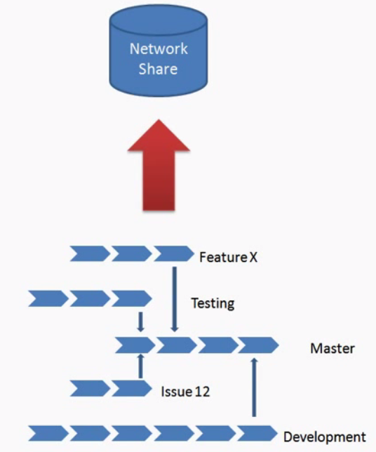

This will have all branch history to N/W share. It’s Ok Not a big deal.

But if we are working for a long time. When Integration and merging integration happens.., all of branches must be Merged and integrated with what’s on N/W share.So we can use rebase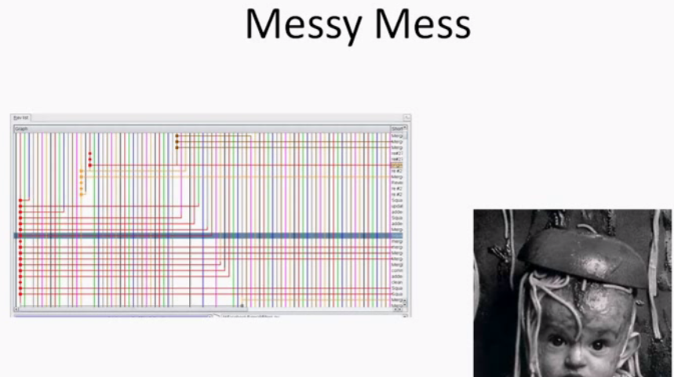

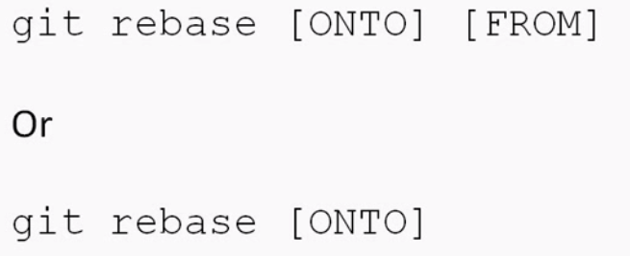

1. Let say we have 2 branches going. **We want to rebase devt. Onto master**

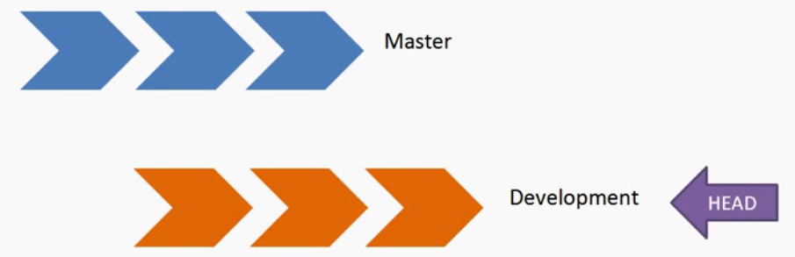

1. Relocate your head to devt branch

Git checkout devt

1. Run git rebase master

It will take all commits, and essentially patch them onto master branch.

1. Master status still points way back,.Devt points where it is.
2. If we change HEAD between two.., it will point to same commit history.
3. But if we want to merge now, which makes really easy.
4. 

Fast forward.., Easiest merge we can do possibly do

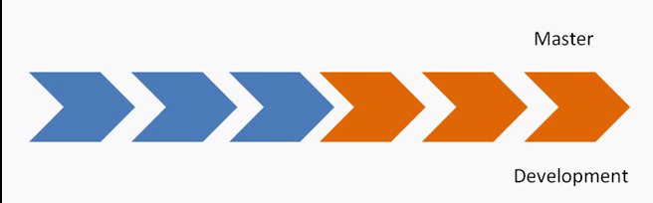

**That’s a nice clean history.., integrating with other branches**



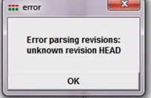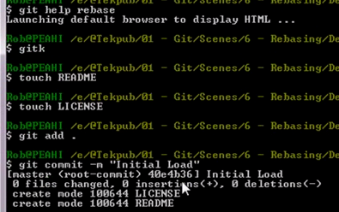

**Gitk🡪 Show me visualization for current branch**

**As there is no element added after creating repo.., no master branch..SO error**

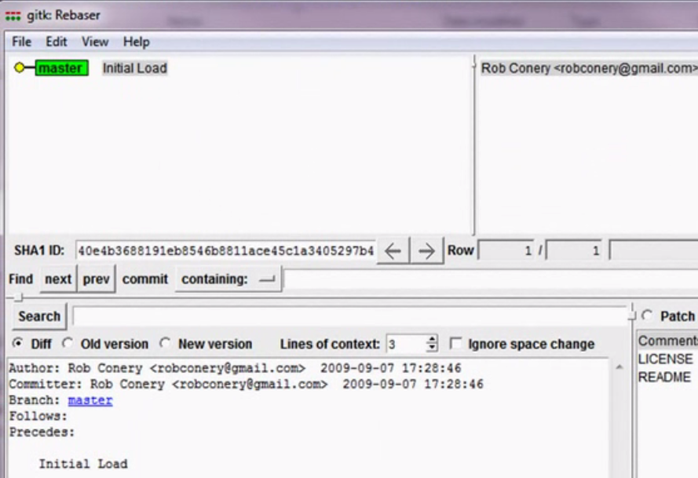

**Green-> Branch currently ON**

**Yellow-> Head is pointing to**

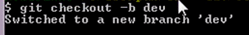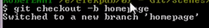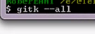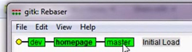

All 3 branches here.., point to same commit. **All have same ancestor**

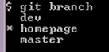

**Add some files to branches**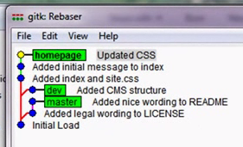

**Blue here is over commit**

**Yellow: current commit pointed to..**

**Branched off from “Initial load”.., master🡪 moved 2 commits**

**Branched off from “Initial load”..,🡪homepage**

**Branched off from “Initial load”..,🡪dev**

**Now, I want to cleanup.**

**I want to have master and homepage have exact same history. So I can rebase homepage onto master.**

**Git checkout homepage**

**Git rebase master🡪 It’s going to apply patches, what that I have done on homepage onto master**

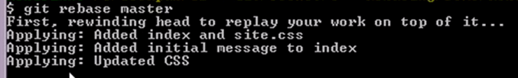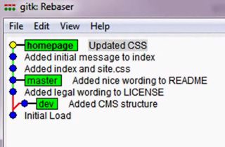

Now, we can see nice clean history. We can still notice master is still pointing to back to commit because we haven’t really merged commit. We only overlayed commit history.

Now, we have to push master forward

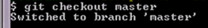

**Just fast forward…Simplest merge**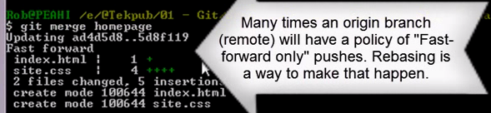

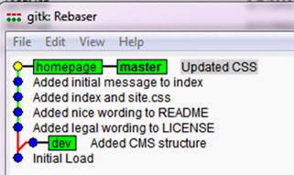

**Now, homepage, master point to same thing.**

**Now, we are done with home branch.., We can cleanup bit here**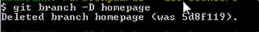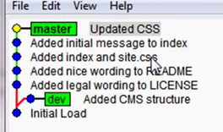

**We don’t really need history.., if it is locally working**

**WORKING WITH REMOTES**

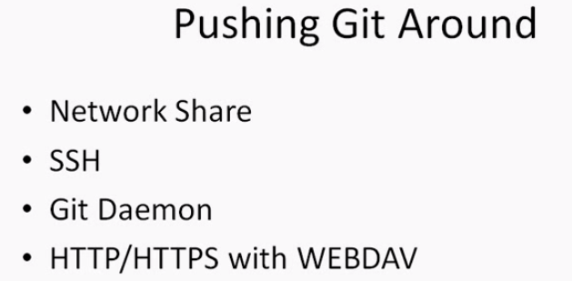

**WHAT IS SSH?**

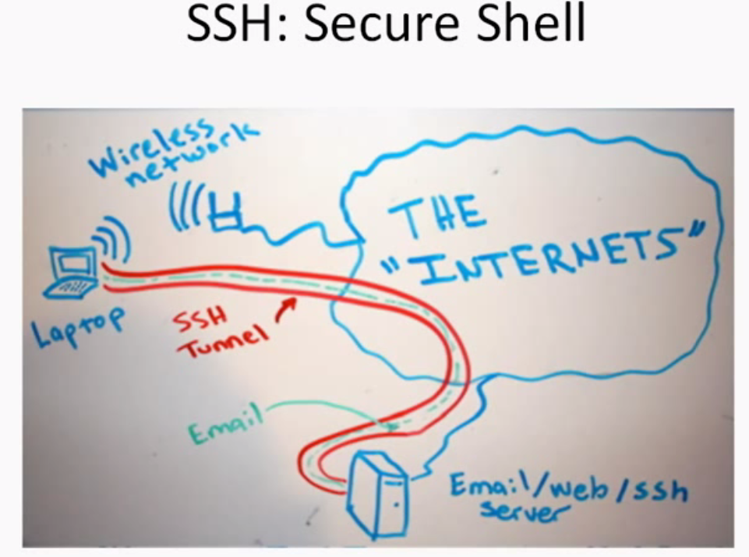

When I’m working on command line, I keep calling bash.

A shell allows access to OS to work on top of it.

When we use SSH, We are tunneling into server and opening up a session to work with OS including things copying files.., setting permissions etc...

It means we are sitting on server command line using SSH.

Generally in windows SSH wont be installed or used . But when we install msysgit, it will ask in very beginning..You want to use OpenSSH or putty. It will install Openssh.

Git will use at its core..,default protocol for pushing branches around n/w.





When we clone github repo or fork one down to ur m/c. this is done using SSH

In this case: git@github.com is host. User-> a/c name.

Clone is command that pulls down to machine.

If we don’t have write access to repo., we need to use git daemon…Read-only



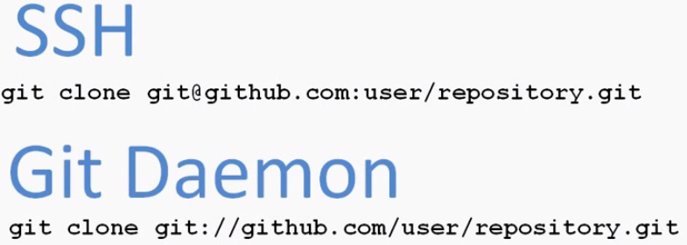

For windows, we can use windows N/W share for repo of any team size.. It works with local acess or VPN.It will help to have BACKUP Scenerio as well as sharing with team.

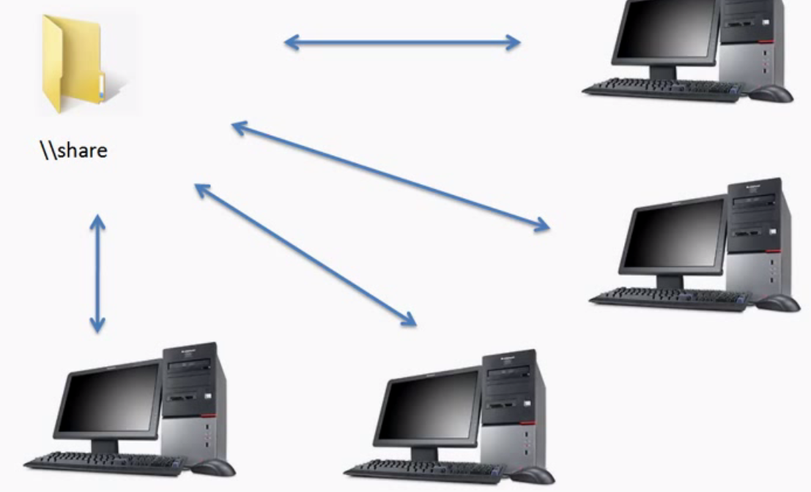

We have shared dir... Various developers push & pull from it.

Merging their branches as required.



1.)

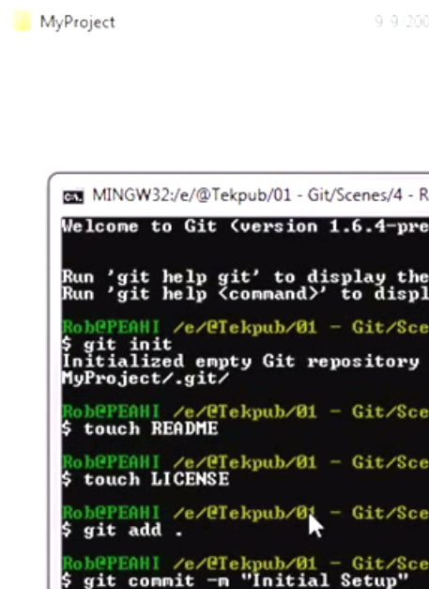

1. System Admin---Remote---BARE REPO

A folder write access to everyone.

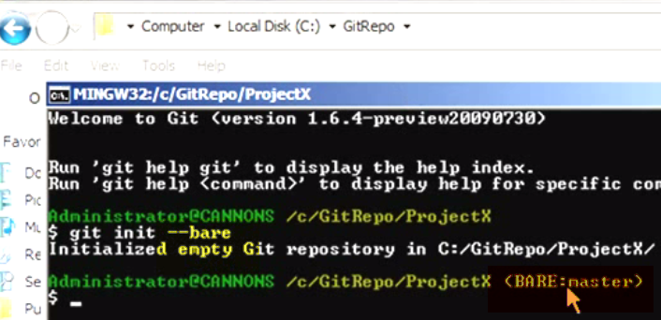

3.)



Add to Z drive on local PC

4.)

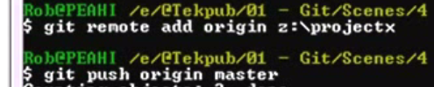

1. Use different User…Shanon

Change user,email in git options.

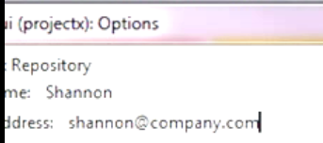

Mapped n/w drive to z drive

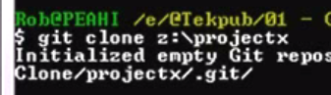

**Inside DIR, we have project folder**

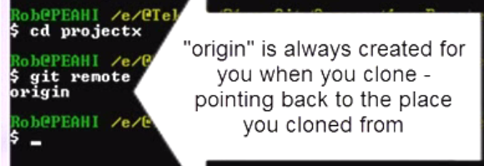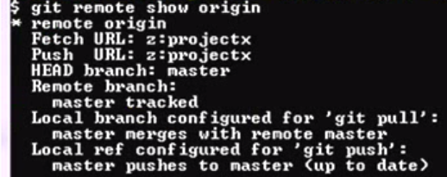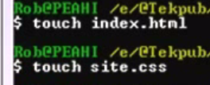





1. **Other user**



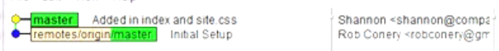

**Initial setup->Rob**

**Add css,index🡪 Shannon**



* Screwup and want to change history.
* Change last commit message.
* Waiped out commit, and want to be back

Mistakes repo



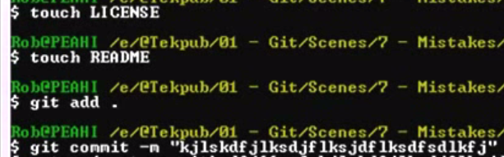

SEE commit MESSAGE

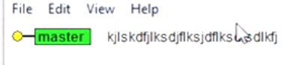

1. Change commit message



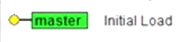

Message changed now.

1. **Forget to add a file to last commit(AMMEND TO LAST COMMIT)**

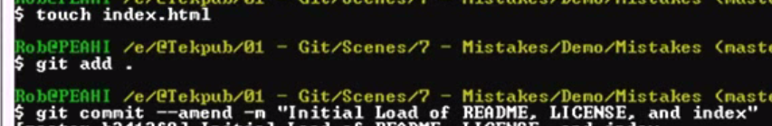

**Added a file index.html, and amended to last commit**

1. 

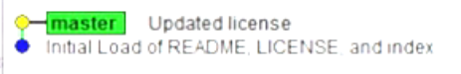

**We now, want to make commit out**



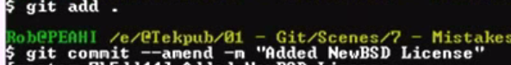

**Ammended over my last commit**

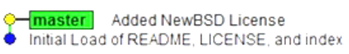

**Now, no record of putting old license file(Update License)..**

**2 ways:**

**Ammend:**

* **Go back and change license**
* **Add a missed file and change initial message**

**Reverting**

**notepad license**

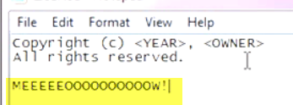

**Notepad README  
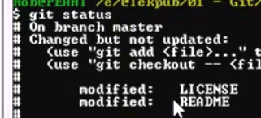**

**These 2 files are modified**

**What modified??---git diff (Working changes vs last commit)**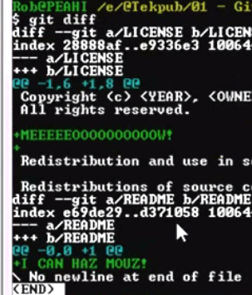

**Revert back to last commit**

**2 ways**

* **Gui**
* **Command line**



**Fire everything off of working directory, until last commit**

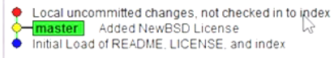

**HEAD->master**

**There are some uncommitted chaNges**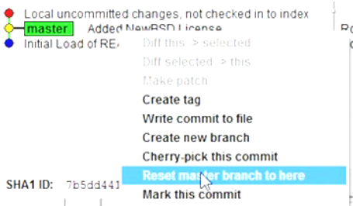

**Make sure we reset everything using HARD**

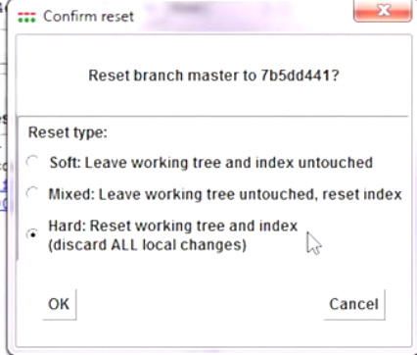

1. 

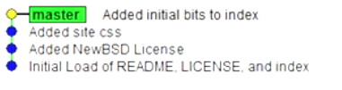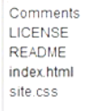

**We added license, css, index.html**

**I don’t want to goto till License only**

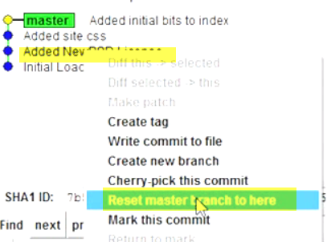

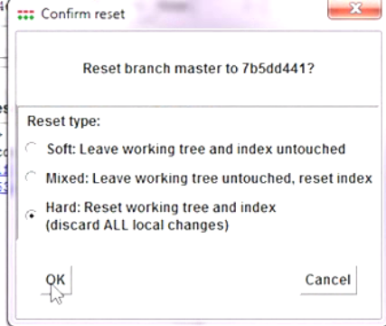

**I lose everything** 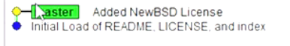

**CSS lost**

**What to do if, want to get CSS back ---using reflog**

**Git tracks everything we do**

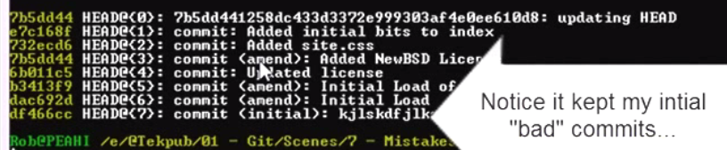

**Notice it has bad commits as well**

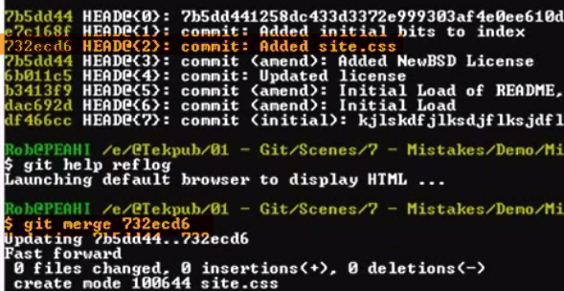

**FAST FORWARD**

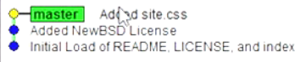

1. 

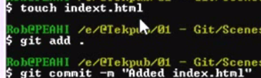

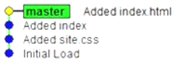

**Revert and delete file here**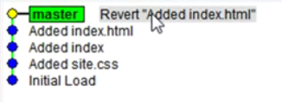

**Now master is pointing to new commit ---Revert added index.html**

**Now, u can’t find index.html**

**Git extensions.**

**Kdiff comes along with this**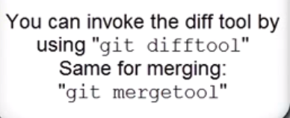

**File Browser**

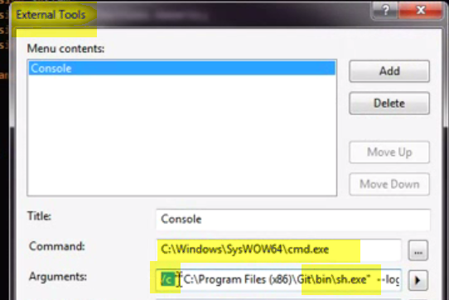****

**How git stores in it**

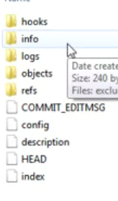

1. **Hooks:** We can code and hook to certain points
2. **Description:**

“Unnamed repository; edit this file 'description' to name the repository”

We can edit it



1. **Config:**

**All config stuff stored for local repo**

**Open git-gui and change user name in options.** 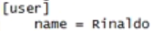

**COMMIT_EDITMSG: Shows last commit done**

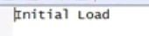

**Storage mechanism:**

1. **HEAD: Which branch you are working on**

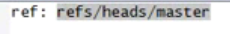

1. **Goto refs/head.Open master file**

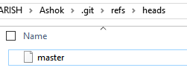

**Here we have checksum, that points to specific commit.**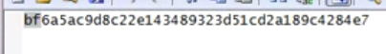

1. **1st look at 2 letters..Goto .git/objects**

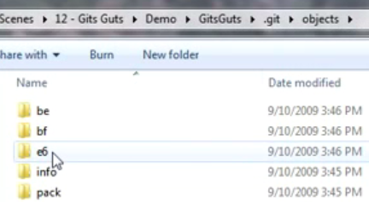

**We can see bf folder. Inside that**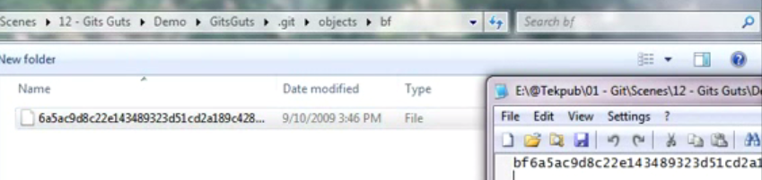

**Rest of equation.**

**This tells commit object is pointing to** 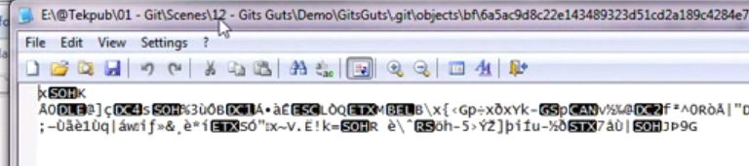

**A fat binary commit objects.**

**This goes on with other objects to pull together all files.**

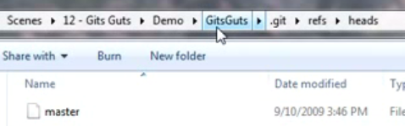

**We can change this, by opening bash.**

**Add branch**

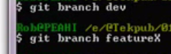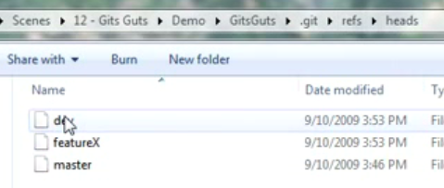

**Now, we have different heads.**

**1 for each branch**

**Master:**



**FeatureX**



**Dev**



**All these points to same.**

**OK…??? But how to I know, which one my repository is currently using??**

**Go to HEAD**

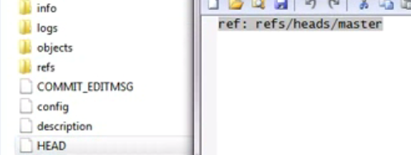

1. **Changing this**

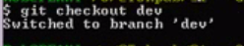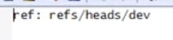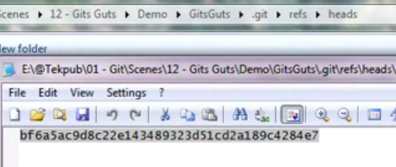

1. **LOGS**

**HEAD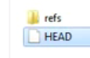🡪 where HEAD is pointed to.**

**And last 2 commit messages**

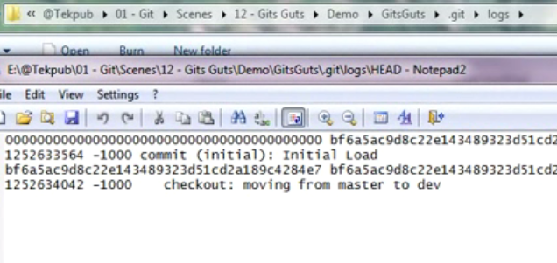

1. **HOOKS:**

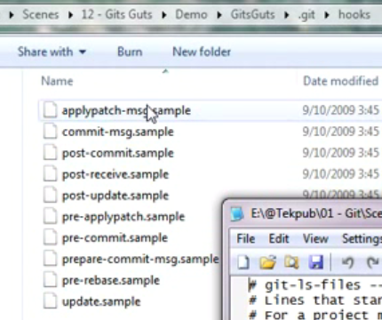

**None are firing..If we want to fire them, we want to remove .sample**

**These are divided into 2 groups:**

**Client and server.**

**Pre-cmooit, post-cmmot 🡪 client**

**Post-receive🡪 server🡪 when we receive push from remote branch**

**11.)Index:**

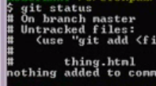

**Here in git status, it shows we have new file thing.html**

**Now, it is put into staging dir🡪 tempo area.**

**That area here is index.**

**That’s a BINARY BLOB**



TAGGING

Bookmark

Identify commit with a message/name

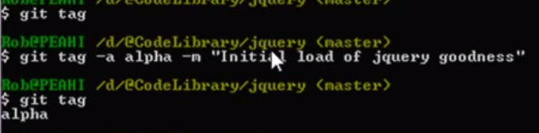

Now push those tags to github

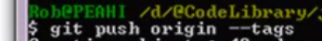

Now it helps people to download,based on tags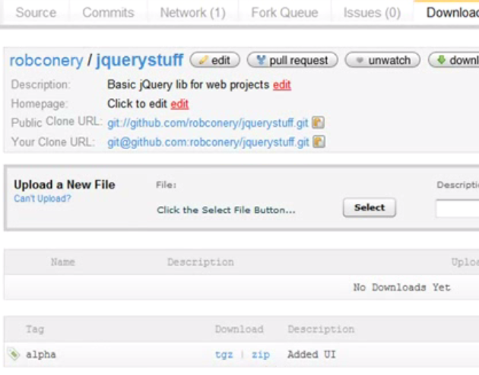

**TAG a specific release/commit**

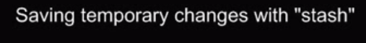

**If we are working on something,and want to switch branches without commiting**

**Goback and work on features.**

**We even don’t want to commit and also stage or lose either**

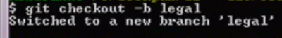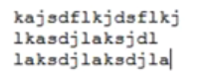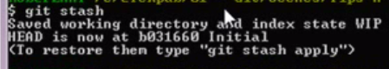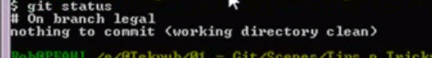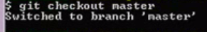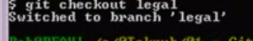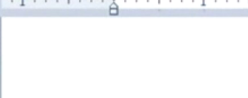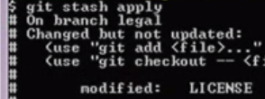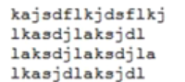

1. **If we don’t want to work with stash anymore**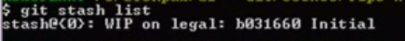

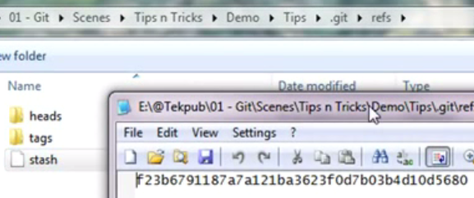



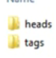

**3.)**

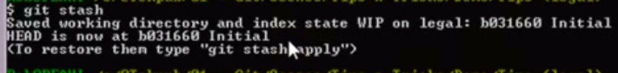

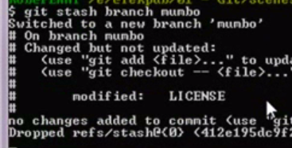

**Switched to branch Mombo. We have changes all in there.**



**Write script for SVN**

**MSbuild using TFS**

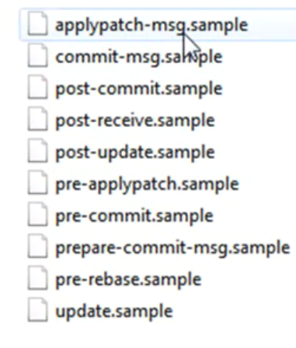

**Server, client side**

**Most of client side.**

**Psot-recive, post-update,update🡪server scripts.**

**Post-recive fire when someone push to repo.**

